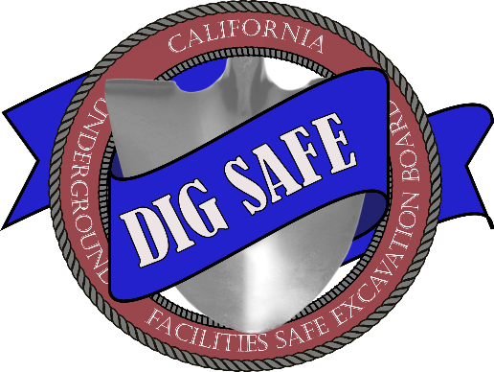

AREA OF CONTINUAL EXCAVATION AGREEMENT

FLOOD CONTROL FACILITIES
(Government Code section 4216.10 and California Code of Regulations, title 19, sections 4002 and 43614300 and 4350-4351)
This Agreement must be completed legibly in ink or typed. Signatures must be handwritten in ink.
Excavator and Operator with assets located in property where flood control facilities are present are required to complete this Area of Continual Excavation Agreement – Flood Control Facilities (Form No. ACE Agreement 02 (09-01-202307-01-2020)) (“Agreement”) for a Continual Excavation Ticket for continual excavation within 10 feet of the Operator’s high priority subsurface installation. Excavation described in this Agreement may be performed up to one year after the Excavator obtains a Continual Excavation Ticket, which may be renewed within two (2) working days by calling “811” or accessing the regional notification center’s (“one-call center”) website. This Agreement applies to only ONE Operator. Other high priority subsurface installations may be present on the property, and a separate Area of Continual Excavation Agreement – Flood Control Facilities (Form No. ACE Agreement 02 (09-01-202307-01-2020)) is required with each Operator.
CONTINUAL EXCAVATION TICKET NUMBER: ______________________________________
DATE OF ONSITE MEETING: ______________________________________
TIME OF ONSITE MEETING: ______________________________________
LOCATION: ______________________________________
(Parcel number, GPS Coordinates, or Description)
EXCAVATOR: ______________________________________
EXCAVATOR REPRESENTATIVE: ______________________________________
PHONE NUMBER: ______________________________________
EMAIL: ______________________________________
OPERATOR: ______________________________________
OPERATOR REPRESENTATIVE: ______________________________________
PHONE NUMBER: ______________________________________
EMAIL: ______________________________________

HIGH PRIORITY SUBSURFACE INSTALLATION DESCRIPTION:
Size, Materials, Operating Pressures, etc.

HIGH PRIORITY SUBSURFACE INSTALLATION LOCATION:
Operator must provide information to assist in verifying the location of the high priority subsurface installation.

FLOOD CONTROL FACILITIES EXCAVATION DESCRIPTION:
Describe all activities involving excavation that may be conducted within 25 feet of each side of the high priority subsurface installation, including method, tools and equipment, depth of excavation, subcontractors (if any), etc.

REQUIRED CHECKLIST:
 | Onsite Meeting | Onsite Meeting between Excavator and Operator (onsite meeting must include the 1) Operator or Operator’s authorized representative with knowledge of the location of the high priority subsurface installation and authority to develop and sign this Agreement, such as a superintendent, supervisor, or engineer; and 2) Excavator or Excavator’s authorized representative with knowledge of the excavation that will occur in the area of continual excavation during the year and authority to develop and sign this Agreement). Discussion and agreed terms and conditions must be documented in this Agreement.
 | Signature & Distribution | Excavator and Operator sign this Agreement and copies are distributed to both parties.
This Agreement applies only to the excavation activities documented in this Agreement. Any deviating activities such as work requiring greater excavation depth or other tools or equipment are beyond the scope of this Agreement. All work outside the scope of this Agreement require separate Tickets and shall be performed in accordance with Government Code section 4216 et seq.
Each party will notify the other of any unexpected occurrences (ex., fire, flood, earthquake or other soil/geologic movement, riot, accident, sabotage, damage to the high priority subsurface installation requiring immediate repair) or excavation activities that may be in conflict with the high priority subsurface installation. The Excavator shall notify the one-call center of any damage to the high priority subsurface installation in accordance with California Code of Regulations, title 19, section 4100.
Prior to conducting excavation activities described in this Agreement, Excavator will communicate information about the terms and conditions under this Agreement to all workers, including any subcontractors, who perform excavation work in the area of continual excavation.
EXCAVATOR:
Signature | Name | Title | Date
OPERATOR:
Signature | Name | Title | Date

