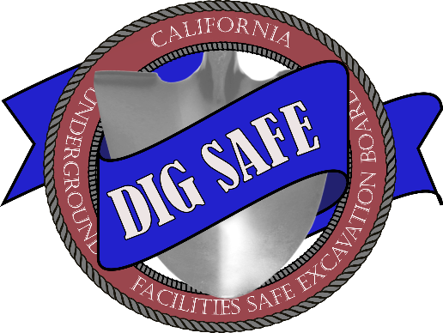
AREA OF CONTINUAL EXCAVATION AGREEMENT
AGRICULTURAL OPERATIONS
(Government Code section 4216.10 and California Code of Regulations, title 19, sections 4002 and 43514300-4302)
This Agreement must be completed legibly in ink or typed. Signatures must be handwritten in ink. Excavator (“Farm Owner/Lessee”) and Operator (“Utility Owner”) with assets located in Farm Owner’s/Lessee’s property are required to complete this Area of Continual Excavation Agreement – Agricultural Operations (Form No. ACE Agreement 01 (09-01-202307-01-2020)) (“Agreement”) for a Continual Excavation Ticket for farming activities involving excavation within 10 feet of the Utility Owner’s high priority subsurface installation (“Utility”). Farming activities described in this Agreement may be performed up to one year after the Farm Owner/Lessee obtains a Continual Excavation Ticket, which may be renewed within two (2) working days by calling “811” or accessing the regional notification center’s (“one-call center”) website. This Agreement applies to only ONE Utility Owner. Other Utilities may be present on the property, and a separate Area of Continual Excavation Agreement – Agricultural Operations (Form No. ACE Agreement 01 (09-01-202307-01-2020)) is required with each Utility Owner.
CONTINUAL EXCAVATION TICKET NUMBER: ______________________________________
DATE OF ONSITE MEETING: ______________________________________
TIME OF ONSITE MEETING: ______________________________________
LOCATION: ______________________________________
(Parcel number, GPS Coordinates, or Description)
FARM OWNER/LESSEE: ______________________________________
FARM OWNER/LESSEE REPRESENTATIVE: ______________________________________
PHONE NUMBER: ______________________________________
EMAIL: ______________________________________
UTILITY OWNER: ______________________________________
OWNER REPRESENTATIVE: ______________________________________
PHONE NUMBER: ______________________________________
EMAIL: ______________________________________
UTILITY DESCRIPTION:
Size, Materials, Operating Pressures, etc.
UTILITY LOCATION:
Utility Owner must provide information to assist in verifying the location of the Utility.
FARM OPERATION DESCRIPTION:
Describe all farming activities involving excavation that may be conducted within 25 feet of each side of the Utility, including method, tools and equipment, depth of excavation, subcontractors (if any), etc.
REQUIRED CHECKLIST:
 | Onsite Meeting | Onsite Meeting between Farm Owner/Lessee and Utility Owner (onsite meeting must include the 1) Utility Owner’s authorized representative with knowledge of the location of the Utilities, and authority to develop and sign this Agreement, such as a superintendent, supervisor, or engineer; and 2) Farm Owner/Lessee or Farm Owner’s/Lessee’s authorized representative with knowledge of the farming activities involving excavation that will occur in the area of continual excavation during the year, and authority to develop and sign this Agreement). Discussion and agreed terms and conditions must be documented in this Agreement.
 | Signature & Distribution | Farm Owner/Lessee and Utility Owner sign this Agreement and copies are distributed to both parties.
This Agreement applies only to the farming activities documented in this Agreement. Any deviating activities such as work requiring greater excavation depth or other tools or equipment are beyond the scope of this Agreement. All work outside the scope of this Agreement require separate Tickets and shall be performed in accordance with Government Code section 4216 et seq.
Each party will notify the other of any unexpected occurrences (ex., fire, flood, earthquake or other soil/geologic movement, riot, accident, sabotage, damage to Utility requiring immediate repair) or excavation activities that may be in conflict with the Utility. The Farm Owner/Lessee shall notify the one-call center of any damage to the Utility in accordance with California Code of Regulations, title 19, section 4100.
Prior to conducting farming activities described in this Agreement, Farm Owner/Lessee will communicate information about the terms and conditions under this Agreement to all workers, including any subcontractors, who perform excavation work in the area of continual excavation.
FARM OWNER/LESSEE:
Signature | Name | Title | Date
UTILITY OWNER
Signature | Name | Title | Date

