**SCOPING MEETING**

**Climate Change and**

**Fire Risk-Consequence Modeling**

*An Opportunity to Share Your Expertise*

DAY Tuesday

July 25, 2023

9 a.m. - 4 p.m. PST

Please join us to learn about and discuss incorporating climate change into risk-consequence modeling for wildfire mitigation efforts by utilities.

Location:

**VIRTUAL VIA ZOOM**

Please click the link below to join the scoping meeting:

[https://us06web.zoom.us/j/84619551733?pwd=c2lveDdaektaazcvRlVFNVY1RnZEQT09https://us06web.zoom.us/j/84619551733?pwd=c2lveDdaektaazcvRlVFNVY1RnZEQT09](https://us06web.zoom.us/j/84619551733?pwd=c2lveDdaektaazcvRlVFNVY1RnZEQT09)

**Passcode**: 331007

FACILITATED BY:

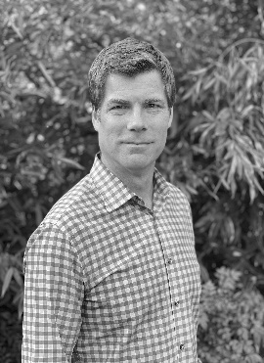

**Michael Wara, JD, PhD**

Director of the Climate & Energy Policy Program & Sr Research Scholar,

Stanford Woods Institute for the Environment

The Office of Energy Infrastructure Safety (Energy Safety) is hosting an initial scoping meeting to share ideas and discuss improvements to Fire Risk-Consequence Modeling by incorporating climate change factors for stakeholders, relevant state agencies, and California’s electrical corporations

In response to increased wildfire risk, California’s utilities have implemented various approaches to mitigate wildfires. Current industry standards and regulations do not provide adequate guidance for applying Risk-Consequence Modeling based on climate-change factors such as aridity, heat, vegetation, and wind.

**Topics of discussion will include:**

* Why include Climate Change in Risk-Consequence Modeling?
* What climate change factors directly impact utilities’ wildfire risk, such as heat, fuel load, aridity, wind, and vegetation?
* How much are utilities currently modeling climate change impacts?
* What tools, research and data sets are utilities currently leveraging?
* How can utilities integrate climate change into their Risk-Consequence Modeling?
* Existing Modeling examples.

For more information about the Office of Energy Infrastructure Safety:

energysafety.ca.gov.